**Prerequisite:** [Generic Trees(N-array Trees)](https://www.geeksforgeeks.org/generic-treesn-array-trees/)

In this article, we will discuss the conversion of the Generic Tree to a Binary Tree. Following are the rules to convert a [Generic(N-array Tree)](https://www.geeksforgeeks.org/generic-treesn-array-trees/) to [Binary Tree](https://www.geeksforgeeks.org/binary-tree-data-structure/):

* The root of the Binary Tree is the Root of the Generic Tree.
* The left child of a node in the Generic Tree is the Left child of that node in the Binary Tree.
* The right sibling of any node in the Generic Tree is the Right child of that node in the Binary Tree.

**Examples:**  
Convert the following Generic Tree to Binary Tree:

[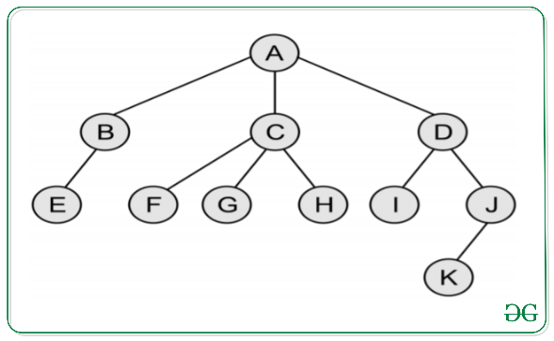](https://media.geeksforgeeks.org/wp-content/uploads/20200324122406/GenricTree.png)

Below is the Binary Tree of the above Generic Tree:

